**Chapter-19**

**Higher order component**

In this chapter we will learn

* **Why we need higher order component?**
* **How to create higher order component?**

Q. create a react app containing a button which indicated number of times you clicked it

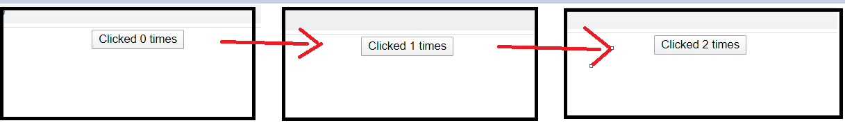

import React, { Component } from "react";

class ClickCounter extends Component {

  constructor(props) {

    super(props);

    this.state = {

      count: 0,

    };

  }

  incrementCount = () => {

    this.setState((prevState) => {

      return { count: prevState.count + 1 };

    });

  };

  render() {

    return (

      <div>

        <button onClick={this.incrementCount}>

          Clicked {this.state.count} times

        </button>

      </div>

    );

  }

}

export default ClickCounter;

Q. create a react app containing a heading which indicated number of times you hover over it

import React, { Component } from "react";

class HoverCounter extends Component {

  constructor(props) {

    super(props);

    this.state = {

      count: 0,

    };

  }

  incrementCount = () => {

    this.setState((prevState) => {

      return { count: prevState.count + 1 };

    });

  };

  render() {

    return (

      <div>

        <h2 onMouseOver={this.incrementCount}>

          Hovered {this.state.count} times

        </h2>

      </div>

    );

  }

}

export default HoverCounter;

In both of these question increment is common functionality and we are not able to use this functionality for these 2 works

* **Why we need higher order component?**

To share common functionality between components

